**Assignment 4**

**Problem Statement:**

You work for a corporation that uses on premise solutions and some limited number of systems. With the increase in requests in their application, the load also increases. So, to handle the load the corporation has to buy more systems almost on a regular basis. Realizing the need to cut down the expenses on systems, they decided to move their infrastructure to AWS.

**Tasks To Be Performed:**

1. Create a Classic Load Balancer and register 3 EC2 instances with different web pages running in them. 2. Migrate the Classic Load Balancer into an Application Load Balancer.

**Solution:**

Step1:- Create 3 EC2 instances & register websites onto them

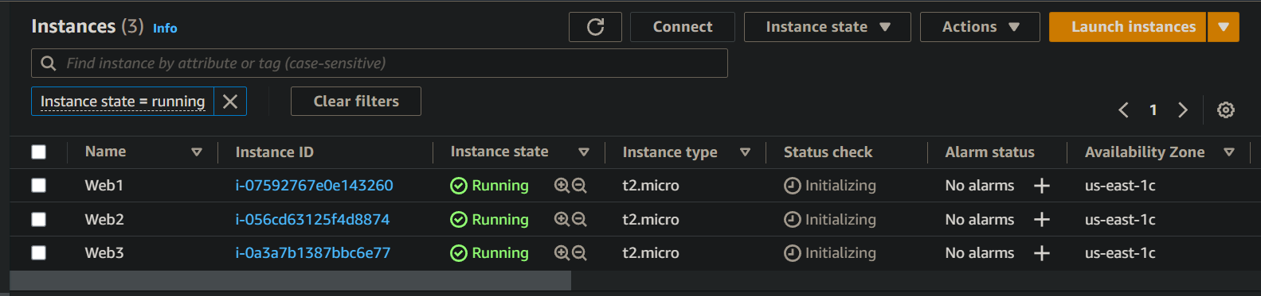

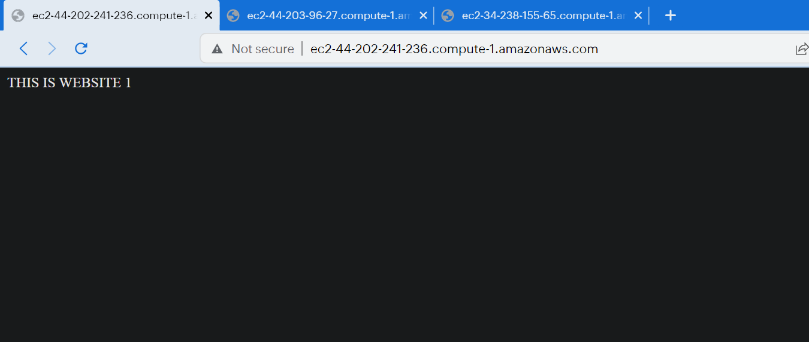

Step2:- Create Classic Load Balancer

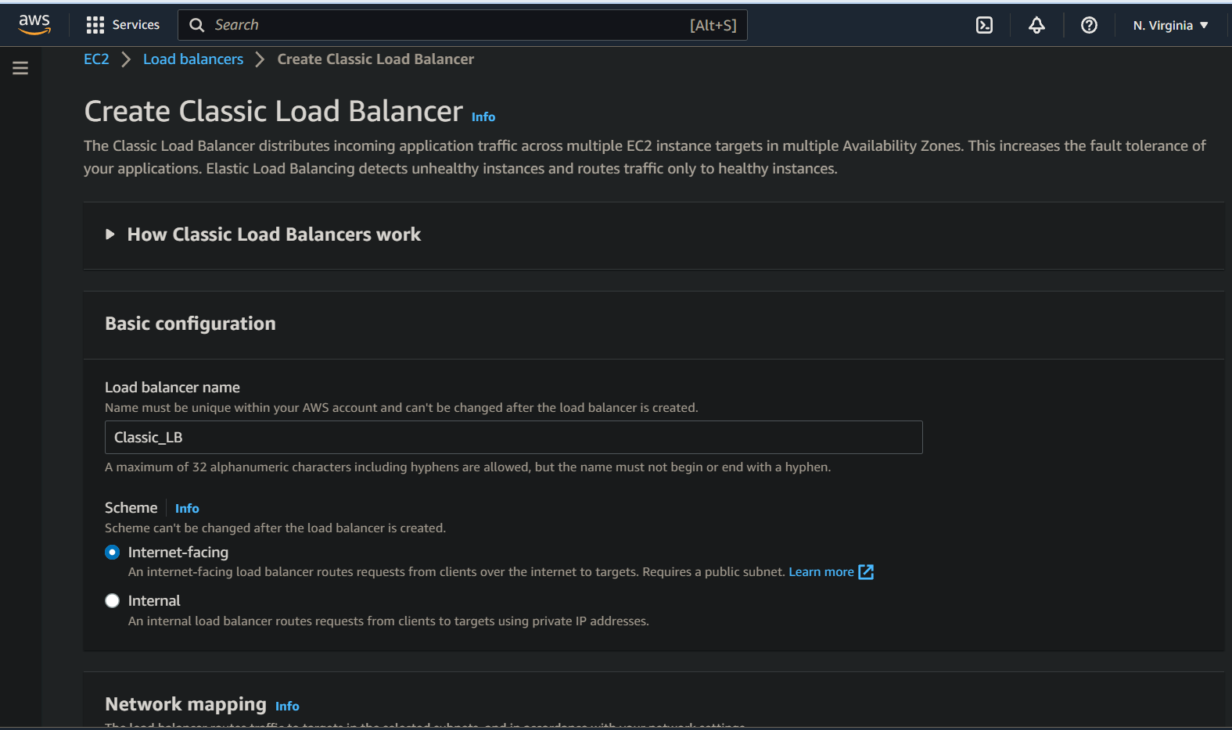

Step3:- Copy the DNS name of Classic LB & check if it redirecting to different web-pages

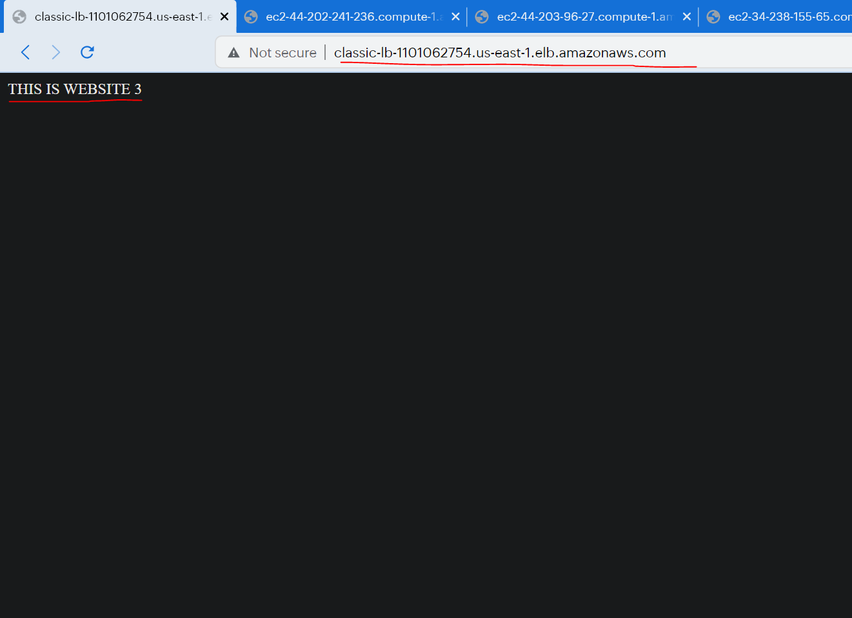

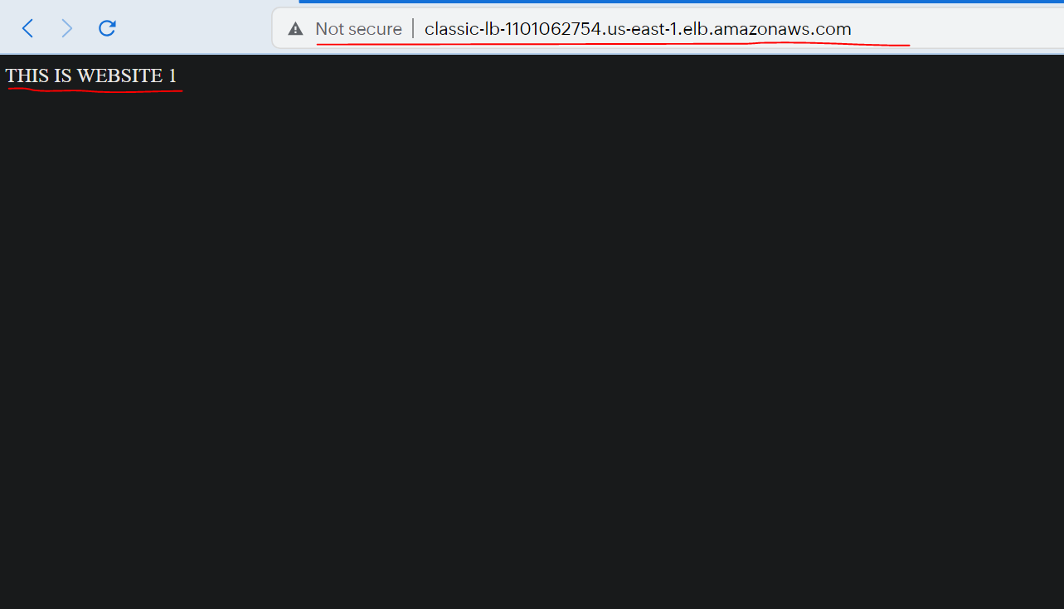

Step 4:- Now to migrate to ALB, click on migrate now in Classic LB description box.

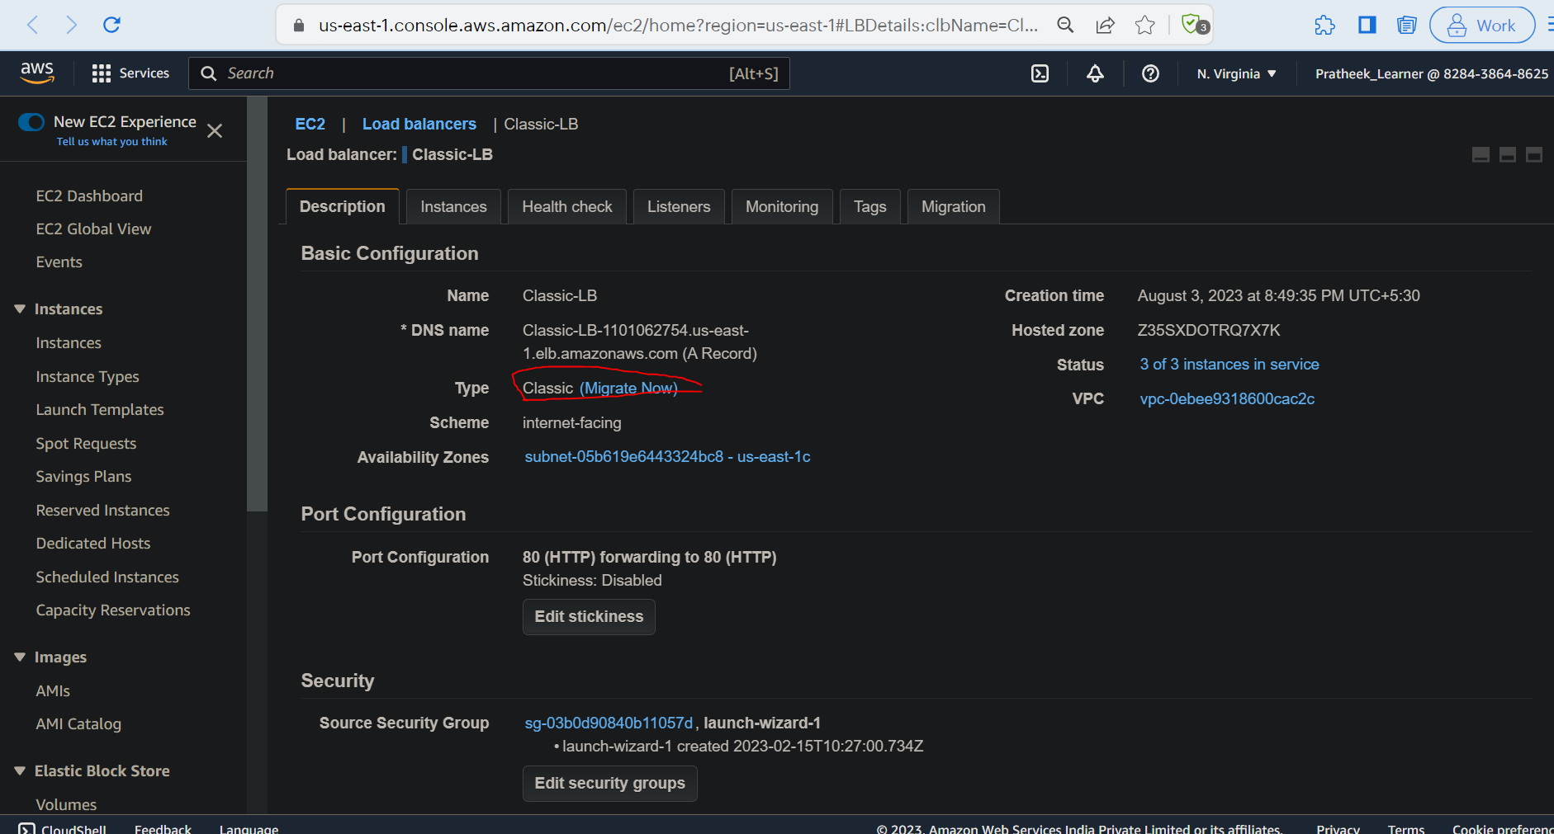

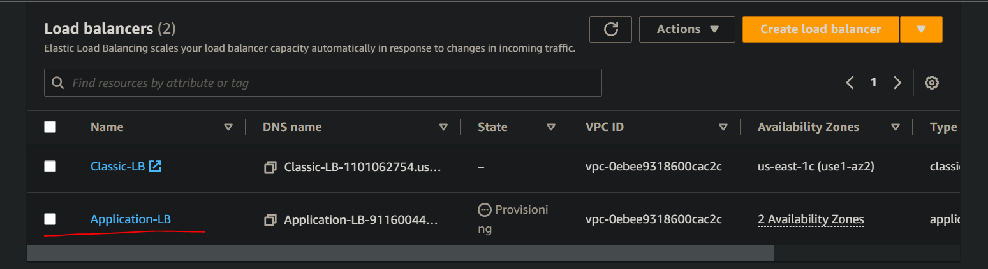

Step 5:- Migration successful.

